Industrial Training Report

A

Report

Submitted

In partial fulfillment

for the award of the degree of

Bachelors in Computer Application



Department of Computer Science

Apex University

Apex School of Computer & IT

July-2021

Submitted by-

Mr. Kunal Jain

Enrollment No.:19CA151M50T011

Supervisor-

Mr. Rishank Sharma

Assistant Professor

**CERTIFICATE BY COMPANY / INDUSTRY**



INDUSTRY/ ORGANISATION LETTER HEAD …………………………………………………………………………………

Date: …………....

CERTIFICATE

This is to certify that Mr. Kunal Jain studying in Second Year B.C.A. in Apex University, Jaipur has undergone Industrial Internship Training in our organization from 01-07-21 to 01-08-21

SIGNATURE WITH SEAL

COURSE CODE .............. INDUSTRIAL INTERNSHIP TRAINING

**BONAFIDE CERTIFICATE**

Certified that this Industrial Internship Training Report titled The Sparks Foundation is the bonafide work of Mr. Kunal Jain who carried out the training work under my supervision. Certified further, that to the best of my knowledge the work reported here in does not form part of any other project report or dissertation on the basis of which a degree or award was conferred on an earlier occasion on this or any other candidate.

[NAME] [NAME]

Head Internship Coordinator

Department of …………. Department of ……….

Submitted for the Industrial Internship Training Viva-Voce examination held on

Examiner Examiner Examiner Examiner

COURSE CODE ........... INDUSTRIAL INTERNSHIP TRAINING

**DECLARATION**

I affirm that the Industrial Internship Training report titled “INDUSTRIAL INTERNSHIP TRAINING AT THE SPARKS FOUNDATION, SINGAPORE” being submitted in partial fulfillment of the requirements for the award of the Degree of BACHELOR OF COMPUTER APPLICATION IN WEB DEVELOPMENT & DESIGNING is the original work carried out by me. It has not formed the part of any other project work submitted for award of any degree or diploma, either in this or any other Institution.

(Signature)

Name of the Student : Kunal Jain

Enrollment No.19CA151M50T011

I certify that the declaration made above by the candidate is true

(Signature)

Name of the Internship Coordinator

Department of ……………………

**Table of Contents**

CERTIFICATE BY COMPANY/INDUSTRY........................................................................

LIST OF FIGURES...................................................................................................................

ACKNOWLEDGEMENT..........................................................................................................I

ABSTRACT..............................................................................................................................II

CHAPTER - 1...........................................................................................................................1

INTRODUCTION......................................................................................................................1

1.1 About Company...................................................................................................................1

1.2 About GRIP..........................................................................................................................2

1.3 About HTML........................................................................................................................3

1.4 About CSS............................................................................................................................4

1.5 About JavaScript..................................................................................................................5

CHAPTER - 2............................................................................................................................7

Features, Version and Advantages / Disadvantages of HTML, CSS and JavaScript................7

2.1 Version Of HTML................................................................................................................7

2.2 Features of HTML................................................................................................................8

2.3 Advantages / Disadvantages Of HTML...............................................................................9

2.4 Version Of CSS....................................................................................................................9

2.5 Advantages / Disadvantages Of CSS.................................................................................10

2.6 Features Of JavaScript.......................................................................................................11

2.7 Application / Limitation of JavaScript...............................................................................11

CHAPTER - 3..........................................................................................................................13

OVERVIEW OF THE TRAINING.........................................................................................13

3.1 Summary of the training: ...................................................................................................13

Task-1 Payment Gateway Integration......................................................................................13

CHAPTER - 4..........................................................................................................................14

WORKING OF TASKS...........................................................................................................14

Task-1 Payment Gateway Integration......................................................................................14

Home Page...............................................................................................................................14

Donation Page..........................................................................................................................15

Donation Amount ....................................................................................................................16

Select Payment Method............................................................................................................17

Payment Success......................................................................................................................18

Payment Receipt.......................................................................................................................19

CONCLUSION........................................................................................................................20

References................................................................................................................................21

**LIST OF FIGURES**

Figure 1.1 Logo of The Sparks Foundation….……………………………...………………...1

Figure 1.2 GRIP logo …………………………………………………………..…..………….2

Figure 1.3 HTML logo ………………………………………………………………………...3

Figure 1.4 CSS logo…………………………………………………………………………...4

Figure 1.5 JavaScript logo…………………………………………………………………….5

Figure 4.1 Donate For A Cause………..……………………………………………………..14

Figure 4.2 Donate Now………...…………………………………………………………….15

Figure 4.3 Enter Amount…..…………………………………………………………………16

Figure 4.4 Payment Method………………………………………………………………….17

Figure 4.5 Payment Received……………..………………………………………………….18

Figure 4.6 Receipt……………………………………………………………………………19

**ACKNOWLEDGEMENT**

I am thankful **Mr.Pranav Dubey** for providing me a platform for my 1 month training/internship in The Sparks Foundation.

I would also like to thank and show my gratitude to **Mr.Rishank Sharma** who helped me in successful completion of my 2nd Year Industrial Training. They have guided, motivated & were source of inspiration for me to carry out the necessary proceedings for the training to be completed successfully.

I would also like to express my hearts felt appreciation to all my friends who direct or indirect suggestions help me to develop this project.

Lastly, thanks to all faculty members for their moral support and guidance.

**ABSTRACT**

Summer training in Web Development has been done by me under the Industrial Training Program 2021 issued under Apex University norms. It is a 30 days training program which is done under the platforms “**The Sparks Foundation**”. During the training period I have learned about the HTML, CSS, JavaScript concepts, through web development. This report genuinely carries all the information about this training as well as its certificate information which I have get during the Industrial Training Program 2021.

**CHAPTER – 1**

**INTRODUCTION**

* 1. **About Company:**

 **Figure 1.1 Logo of The Sparks Foundation**

**The Sparks Foundation** provides the services such as **Education Management, Student Scholarship Program, Student Mentorship Program, Student SOS Program, Student Externships Program**which comes underand serves at **NGOs, Trust, Charitable Institutions**Industry.

The company name has been registered with the CIN number **U74999HR2018NPL072320**and with Key Directors:

• **Pranav Dubey**  
• **Pranjal Dubey**

Its Registered Address is: **354/14, Gurugram Gurgaon Haryana 122002 India.**

The Sparks Foundation. This brand new education Non Profit Organization trying to sell students hope for successful future.The first program that they have successfully put into play for about three months now is their Graduate Rotational Internship Program, or GRIP. This internship program is based completely online as a part-time internship for students to complete in the span of 1 month.

GRIP offers internships for the areas of tech, marketing, and human resources. The first month works on individual tasks, such as writing articles and designing posters, the second month consists of group work. The groups for the second month of the program are based on a personality test that all interns take at the beginning of the program so that all interns are placed into groups that will complement their strengths and weaknesses.

The last month focuses on expanding the interns’ knowledge of the area they are working in. This program has been successfully running for a few months now, and TSF is expanding their programs to include a wider variety of students from a variety of different backgrounds.

  TSF aims to improve not only the education aspect of their school experience but also the personal aspect as well. It is in ways like this that TSF aspires to inspire young people to reach out to achieve their maximum potential both in their educational and personal lives.

TSF wants to ensure that all students have the skills to achieve anything they set their minds to, and if they need an extra step to achieve that, TSF has got them covered.

The mentor is paired up with their mentee and receives scheduled routine progress monitoring so that they do not fall behind. By receiving direct attention, mentors are able to directly see their mentees strengths and weaknesses and work on them accordingly. This is the fastest and most effective way to teach students how to succeed both with their hard and soft skills.

As TSF grows, they have a vision for an even wider array of programs to help an even broader spectrum of students. These programs are only the beginning of visionaries that aim to improve the future of all students, and students are our future. TSF aspires to give hope to improve the lives of our future to improve everyone’s future.

**1.2 About GRIP:**



**Figure 1.2 GRIP Logo**

The **Graduate Rotational Internship Program (GRIP)** is the flagship program of TSF in which students, recent graduates, and professionals focus on technical skills development as well as professional profile improvement on LinkedIn.

We are #hiring #interns in several functions for the JULY21 batch of our GRIP - an opportunity to learn, network and grow and professionals from varied diversity, background, skills and countries . The format of GRIP is a 1-month, unpaid and virtual internship.

**1.3 About HTML:**

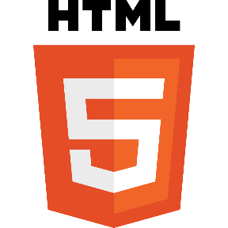

**Figure 1.3 HTML logo**

HTML stands for Hyper Text Markup Language.

HTML is the standard markup language for creating Web pages

HTML describes the structure of a Web page

HTML consists of a series of elements

HTML elements tell the browser how to display the content

HTML elements label pieces of content such as "this is a heading", "this is a paragraph", "this is a link", etc.

[HTML elements](https://en.wikipedia.org/wiki/HTML_element) are the building blocks of HTML pages. With HTML constructs, [images](https://en.wikipedia.org/wiki/HTML_element#Images_and_objects) and other objects such as [interactive forms](https://en.wikipedia.org/wiki/Fieldset) may be embedded into the rendered page.

HTML provides a means to create [structured documents](https://en.wikipedia.org/wiki/Structured_document) by denoting structural [semantics](https://en.wikipedia.org/wiki/Semantics) for text such as headings, paragraphs, lists, [links](https://en.wikipedia.org/wiki/Hyperlink), quotes and other items. HTML elements are delineated by *tags*, written using [angle brackets](https://en.wikipedia.org/wiki/Bracket#Angle_brackets).

Tags such as <**img** /> and <**input** /> directly introduce content into the page. Other tags such as <**p**> surround and provide information about document text and may include other tags as sub-elements. Browsers do not display the HTML tags, but use them to interpret the content of the page.

**1.4 About CSS:**



**Figure 1.4 CSS logo**

**C**ascading **S**tyle **S**heets, fondly referred to as CSS, is a simple design language intended to simplify the process of making web pages presentable.

CSS handles the look and feel part of a web page. Using CSS, you can control the color of the text, the style of fonts, the spacing between paragraphs, how columns are sized and laid out, what background images or colors are used, layout designs, variations in display for different devices and screen sizes as well as a variety of other effects.

CSS is easy to learn and understand but it provides powerful control over the presentation of an HTML document. Most commonly, CSS is combined with the markup languages HTML or XHTML.

Cascading Style Sheet (CSS) is used to set the style in web pages that contain HTML elements. It sets the background color, font-size, font-family, color etc property of elements on a web page.

Types of CSS (Cascading Style Sheet)

There are three types of CSS which are given below:

* Inline CSS
* Internal or Embedded CSS
* External CSS
* **Inline CSS :** Inline CSS contains the CSS property in the body section attached with element is known as inline CSS. This kind of style is specified within an HTML tag using the style attribute.
* **Internal or Embedded CSS :** This can be used when a single HTML document must be styled uniquely. The CSS rule set should be within the HTML file in the head section i.e the CSS is embedded within the HTML file.
* **External CSS :** External CSS contains separate CSS file which contains only style property with the help of tag attributes (For example class, id, heading etc). CSS property written in a separate file with .css extension and should be linked to the HTML document using **link** tag. This means that for each element, style can be set only once and that will be applied across web pages.

**1.5 About JavaScript:**



**Figure 1.5 JavaScript logo**

**JavaScript** is a lightweight, cross-platform, and interpreted scripting language. It is well-known for the development of web pages, many non-browser environments also use it. JavaScript can be used for [**Client-side**](https://www.geeksforgeeks.org/server-side-client-side-programming/) developments as well as [**Server-side**](https://www.geeksforgeeks.org/server-side-client-side-programming/) developments. JavaScript contains a standard library of objects, like [**Array**](https://www.geeksforgeeks.org/arrays-in-javascript/), [**Date**](https://www.geeksforgeeks.org/javascript-date-objects/), and [**Math**](https://www.geeksforgeeks.org/javascript-math-object/), and a core set of language elements like **operators**, **control structures**, and **statements**.

* **Client-side :** It supplies objects to control a browser and its Document Object Model (DOM). Like if client-side extensions allow an application to place elements on an HTML form and respond to user events such as **mouse clicks**, **form input**, and **page navigation**. Useful libraries for the client-side are [**AngularJS**](https://www.geeksforgeeks.org/introduction-to-angularjs/), [**ReactJS**](https://www.geeksforgeeks.org/react-js-introduction-working/), **VueJS** and so many others.
* **Server-side :** It supplies objects relevant to running JavaScript on a server. Like if the server-side extensions allow an application to communicate with a database, and provide continuity of information from one invocation to another of the application, or perform file manipulations on a server. The useful framework which is the most famous these days is [**node.js**](https://www.geeksforgeeks.org/introduction-to-nodejs/).

JavaScript can be added to your HTML file in [two ways](https://www.geeksforgeeks.org/where-to-put-javascript-in-an-html-document/):

* **Internal JS :** We can add JavaScript directly to our HTML file by writing the code inside the <script> tag. The <script> tag can either be placed inside the <head> or the <body> tag according to the requirement.
* **External JS :** We can write JavaScript code in other file having an extension .js and then link this file inside the <head> tag of the HTML file in which we want to add this code.

**History of JavaScript :** It was created in 1995 by Brendan Eich while he was an engineer at Netscape. It was originally going to be named LiveScript but was renamed. Unlike most programming languages, the JavaScript language has no concept of input or output. It is designed to run as a scripting language in a host environment, and it is up to the host environment to provide mechanisms for communicating with the outside world. The most common host environment is the browser.

**Chapter 2**

**Features, Version and Advantages/Disadvantages of HTML, CSS and JavaScript**

**2.1 Version of HTML:**

The different versions of HTML are

* HTML 1.0
* HTML 2.0
* HTML 3.0
* HTML 3.2
* HTML 4.0
* XHTML
* HTML 5

**HTML 1.0 :**The first release of HTML is HTML 1.0 in the world. It has very limited features, what you could do for designing web pages.

**HTML 2.0** : The HTML 2.0 arrived which include the feature of HTML 1.0 plus some new feature of HTML design until January 1997 HTML 2.0 was the standard for web page design.

**HTML 3.0** : HTML 2.0 was served very well but webmaster designing web pages to markup their text and enhance the appearance of their websites. at that time in the web browser market the Netscape is a leading browser introduced new tags and attributes called the **Netscape Extension Tags**. It led to considerable confusion and problems when HTML authors used these tags and attributes and then saw that they didn't work as expected in other browsers.

At that time an HTML working group, led by Dave Raggett, introduced the HTML 3.0 draft which included many new and useful enhancements to HTML.

**HTML 3.2** : As more browser-specific tags were introduced, it became obvious that a new standard was needed. For this reason, the Word Wide Web Consortium (W3C), founded in 1994 to develop common standards for the evolution of the World Wide Web, drafted the **WILBUR** standard, which later became known asHTML 3.2**.** HTML 3.2 captures the recommended practice as of early 1996 and became the official standard in January, 1997. Most, if not all, popular browsers in use today fully support HTML 3.2.

**HTML 4.0** : In the early days, **HTML 4.0** was code-named **COUGAR**. This version introduces new functionality, most of which comes from the expired HTML 3.0 draft. This version became a recommendation in December, 1997 and a standard as of April, 1998. Explorer has done a very good job in implementing the many features of HTML 4.0. Unfortunately, Netscape has not kept pace. The latest version of Netscape Communicator still does not recognize the many tags and attributes introduced with HTML 4.0. This means that a web page that involves HTML 4.0 specific tags will look great in Explorer but can look disastrous in Netscape.

**XHTML** : The XHTML stand for **Extensible Hyper Text Markup Language**. The next major version after HTML 4.0 would be HTML 5.0 and with it would come a bunch of new tags that would do all sorts of wonderful things. That would be a good guess - but it would also be a wrong guess. The next version of HTML after HTML 4 is XHTML**.**

XHTMLis not bringing with it a lot of new tags. The purpose of XHTML is to address the new browser technologies that is sweeping the world. Today web pages are being viewed in browsers through cell/mobile phones, cars, televisions, plus a host of hand-held wireless devices and communicators. Alternate ways to access the internet are continually being introduced. In many cases, these devices will not have the computing power of a desktop or notebook computer and so will not be able to accommodate poor or sloppy coding practices. XHTML is designed to address these technologies. XHTML also begins to address the need for those with disabilities such as the blind and visually impaired to access the internet. Thus web pages written in XHTML will allow them to be viewed on a wide range of browsers and internet platforms.

**HTML 5.0** : HTML 5 is the new web standard. It follows HTML 4 and XHTML. Since the introduction of HTML4, a lot has happened with the web and something needed to be done to address all the new technologies and latest multimedia. HTML5 is the result of cooperation that began in 2006 between the World Wide Web Consortium (W3C) and the Web Hypertext Application Technology Working Group (WHATWG). While HTML5 is still evolving , the latest browsers do support many of the new features and elements in this version.

The basic aim of HTML5 is to provide two things :

1) to improve the language and

2) to support the latest multimedia

In order to accomplish this, some ground rules were established by the W3C and WHATWG. Among them were to reduce the need for external plug-ins such as Flash plug-ins, better handling of errors, and more markup elements (tags) to replace scripting. HTML5 should also be device independent while also keeping it easily readable by us humans.

**2.2 Features of HTML:**

* It is easy to learn and easy to use.
* It is platform-independent.
* Images, videos, and audio can be added to a web page.
* Hypertext can be added to text.
* It is a markup language.

**2.3 Advantages / Disadvantages of HTML:**

**Advantages:**

* HTML is used to build websites.
* It is supported by all browsers.
* It can be integrated with other languages like CSS, JavaScript, etc.

**Disadvantages:**

* HTML can only create static webpages
* For dynamic webpages, other languages have to be used.
* A large amount of code has to be written to create a simple web page.
* The security feature is not good.

**2.4 Version of CSS:**

CSS3 is the latest standard of CSS earlier versions (CSS2). Cascading Style Sheets, level 1 (CSS1) was came out of W3C as a recommendation in December 1996. This version describes the CSS language as well as a simple visual formatting model for all the HTML tags.

CSS2 became a W3C recommendation in May 1998 and builds on CSS1. This version adds support for media-specific style sheets e.g. printers and aural devices, downloadable fonts, element positioning, and tables.

CSS3 became a W3C recommendation in June 1999 and builds on older versions CSS. It has divided into documentation is called as Modules and here each module having new extension features defined in CSS2.

**2.5 Advantages/Disadvantages of CSS:**

**Advantages:**

* CSS plays an important role, by using CSS you simply got to specify a repeated style for element once & use it multiple times as because CSS will automatically apply the required styles.
* The main advantage of CSS is that style is applied consistently across variety of sites.
* Web designers needs to use few lines of programming for every page improving site speed.
* Cascading sheet not only simplifies website development, but also simplifies the maintenance as a change of one line of code affects the whole web site and maintenance time.
* It is less complex therefore the effort are significantly reduced.
* It helps to form spontaneous and consistent changes.
* These bandwidth savings are substantial figures of insignificant tags that are indistinct from a mess of pages.
* Easy for the user to customize the online page
* It reduces the file transfer size

.

**Disadvantages:**

* CSS, CSS1 up to CSS3, result in creating of confusion among web browsers.
* With CSS, what works with one browser might not always work with another. The web developers need to test for compatibility, running the program across multiple browsers.
* After making the changes we need to confirm the compatibility if they appear. The similar change affects on all the browsers.
* The programming language world is complicated for non-developers and beginners.
* Browser compatibility (some styles sheet are supported and some are not).
* CSS works differently on different browsers. IE and Opera supports CSS as different logic.
* There might be cross-browser issues while using CSS.
* There are multiple levels which creates confusion for non-developers and beginners.

**2.6 Features of JavaScript:**

According to a recent survey conducted by **Stack Overflow**, JavaScript is the most popular language on earth.   
With advances in browser technology and JavaScript having moved into the server with Node.js and other frameworks, JavaScript is capable of so much more.

* JavaScript was created in the first place for DOM manipulation. Earlier websites were mostly static, after JS was created dynamic Web sites were made.
* Functions in JS are objects. They may have properties and methods just like another object. They can be passed as arguments in other functions.
* Can handle date and time performs Form Validation although the forms are created using HTML.
* No compiler needed.

**2.7 Application/Limitation of JavaScript:**

**Applications of JavaScript:**

* **Web Development:** Adding interactivity and behaviour to static sites JavaScript was invented to do this in 1995. By using AngularJS that can be achieved so easily.
* **Web Applications:** With technology, browsers have improved to the extent that a language was required to create robust web applications. When we explore a map in Google Maps then we only need to click and drag the mouse. All detailed view is just a click away, and this is possible only because of JavaScript.

It uses Application Programming Interfaces (APIs) that provide extra power to the code. The Electron and React is helpful in this department.

* **Server Applications:** With the help of Node.js, JavaScript made its way from client to server and node.js is the most powerful in the server-side.
* **Games:** Not only in websites, but JavaScript also helps in creating games for leisure. The combination of JavaScript and HTML 5 makes JavaScript popular in game development as well. It provides the EaseJS library which provides solutions for working with rich graphics.
* **Smart Watches:** JavaScript is being used in all possible devices and applications. It provides a library PebbleJS which is used in smartwatch applications. This framework works for applications that require the internet for its functioning.
* **Art:** Artists and designers can create whatever they want using JavaScript to draw on HTML 5 canvas, make the sound more effective also can be used [**p5.js**](https://www.geeksforgeeks.org/p5-js-introduction/) library.
* **Machine Learning:** This JavaScript ml5.js library can be used in web development by using machine learning.

**Limitations of JavaScript:**

* **Performance:**JavaScript does not provide the same level of performance as offered by many traditional languages as a complex program written in JavaScript would be comparatively slow. But as JavaScript is used to perform simple tasks in a browser, so performance is not considered a big restriction in its use.
* **Complexity:**To master a scripting language, programmers must have a thorough knowledge of all the programming concepts, core language objects, client and server-side objects otherwise it would be difficult for them to write advanced scripts using JavaScript.
* **Weak error handling and type checking facilities:**It is weakly typed language as there is no need to specify the data type of the variable. So wrong type checking is not performed by compile.

There are many **JavaScript Frameworks** and libraries available

* Angular
* React
* jQuery
* Vue.js
* Ext.js
* Ember.js
* Meteor
* Mithril
* Node.js
* Polymer
* Aurelia
* Backbone.js

**Chapter 3:**

**OVERVIEW OF THE TRAINING**

**3.1 Summary of the training:**

This is the task that doing throughout an industrial training.

**Task 1 - Payment Gateway Integration:**

Payment Gateway Integration is 1st Task of **The Sparks Foundation.**

There is a simple donate button on homepage, on clicking the donate button, the user will land on the payment page where user can select the amount to be paid and the payment type that includes Credit Card, Net Banking, PayPal and Debit Card.

The process of integrating a payment gateway may seem daunting, but if you want your website to accept online payments it is necessary. Payment gateways **connect the merchant's website and their payment processing bank**, allowing for the secure transference of financial details.

We built it using **HTML, CSS, JAVASCRIPT, BOOTSTRAP, PHP** using **VS Code Editor.**

**Chapter 4: WORKING OF TASK**

**Task-1 Payment Gateway Integration**

**Home Page**

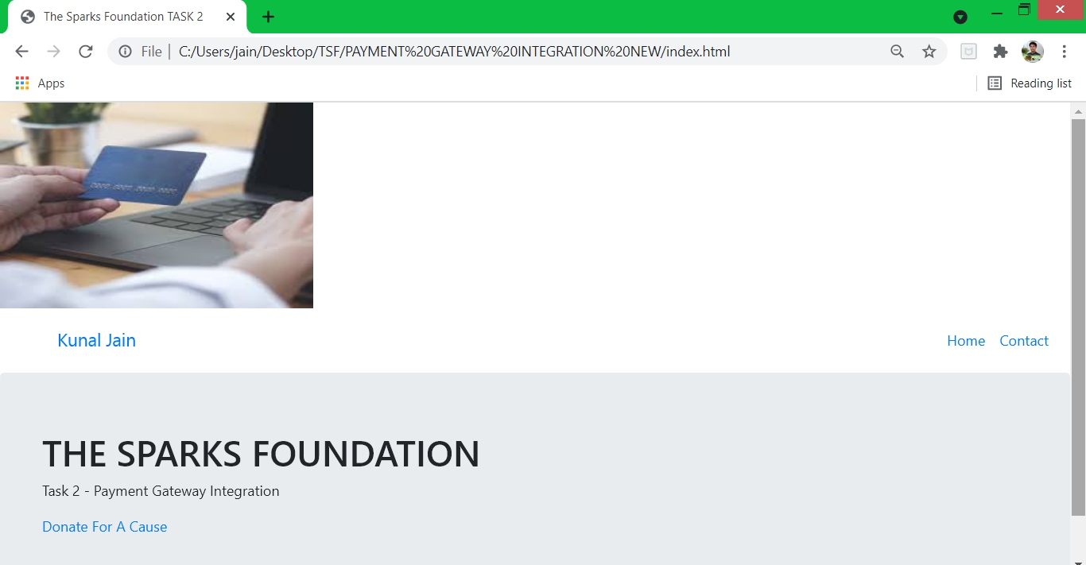

**Fig 4.1 Donate For A Cause**

This Page Contains:

* A button name **Donate For A Cause**.
* When we click on this button Donation Page will open fig. 4.2

**Donation Page**

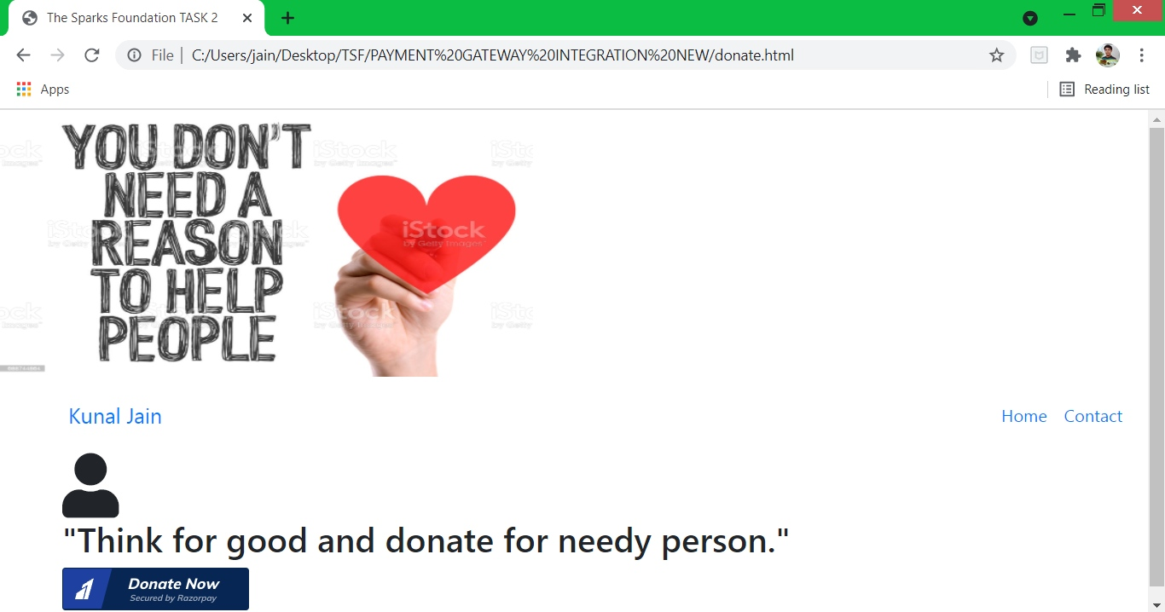

**Fig 4.2 Donate Now**

This Page Contains:

* When a person click on button a **RazorPay Account** is open to donate amount show in Fig 4.3

**Donation Amount**

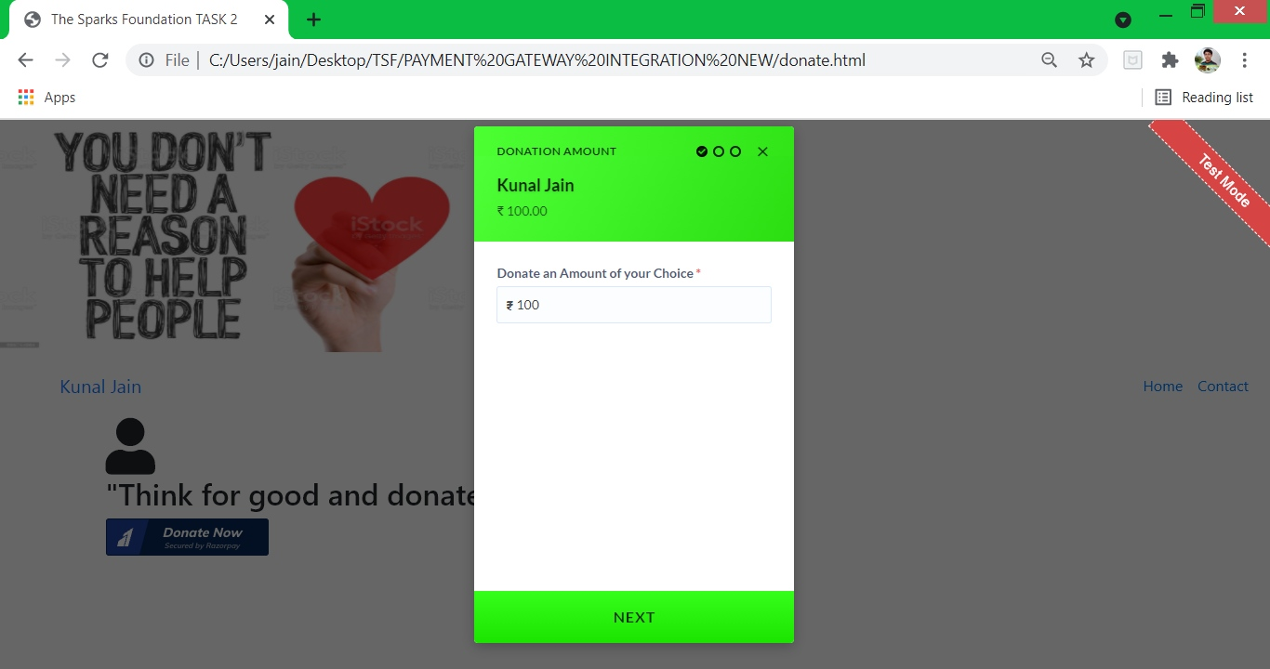

**Fig 4.3 Enter Amount**

This Page Contains:

* Donate an Amount of your choice.
* Then click on **Next** payment method options are visible like Debit/Credit Card, Net Banking, UPI as shown in Figure 4.4

**Select Payment Method**

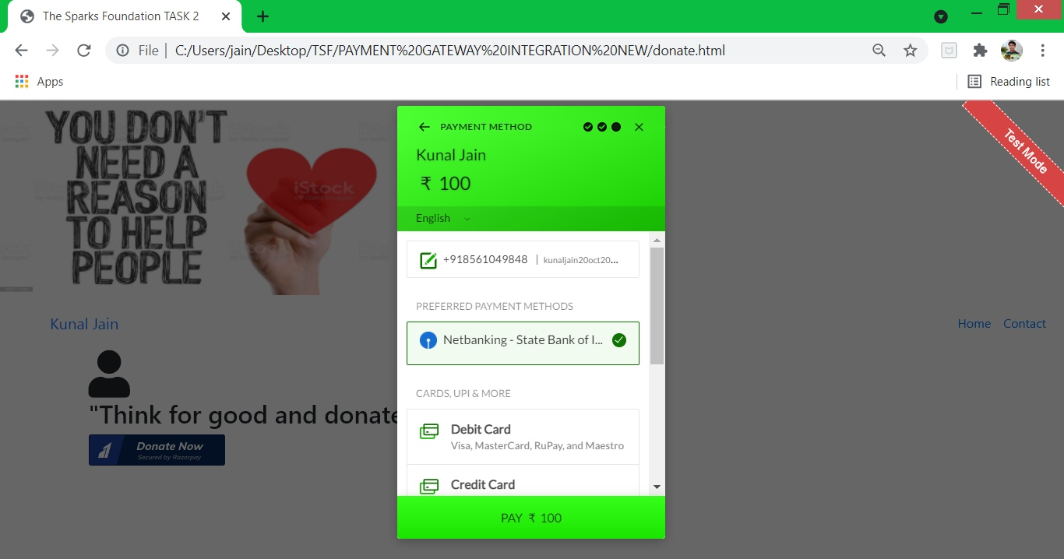

**Fig 4.4 Payment Method**

This Page Contains:

* This page contains all types of cards like **VISA, MasterCard, RuPay.**
* In the NetBanking option there are all types of banks **SBI, ICICI**.
* In the UPI option you can see **PayTm, Google Pay, PhonePay** etc.
* In Wallet you will see **Mobiwik, RazorPay, PayPal** etc.
* After select any option amount will debited from your account and you get the notification of payment success as shown in Fig 4.5

**Payment Success**

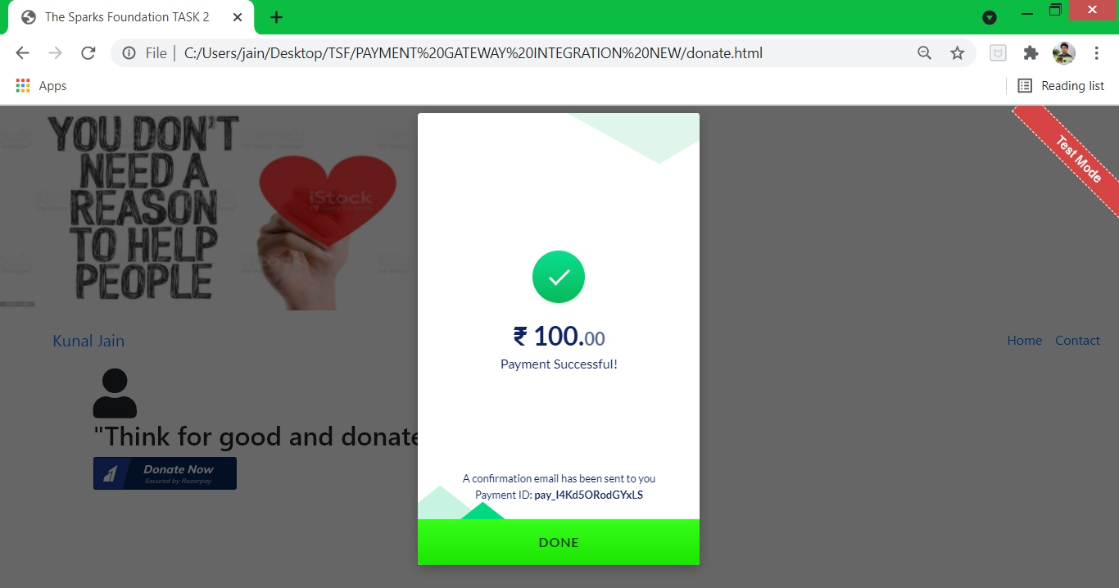

**Fig 4.5 Payment Received**

This Page Contains:

* The confirmation details that how much amount is received from which person on which day, date and time.
* That person will receive an E-mail which contains receipt of payment that how much amount is donate as shown in Fig 4.6

**Payment Receipt**

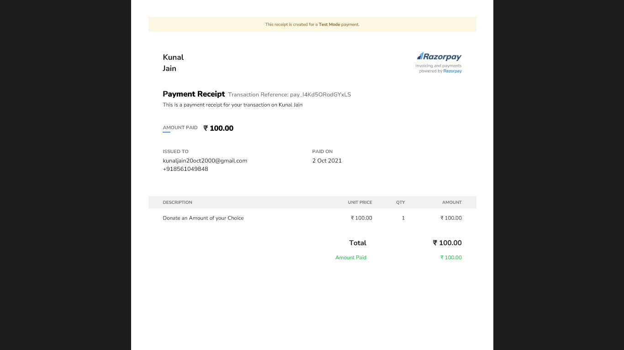

**Fig 4.6 Receipt**

This Page Contains:

* The Receipt contains how much amount is donate, Name, Phone No., E-mail ID and Date.

**Chapter 5**

**CONCLUSION**

**Conclusion:** On the whole, this internship was a useful experience. I have gained new knowledge, skills and met many new people. I achieved several of my learning goals, however for some the conditions did not permit. I got insight into professional practice. I learned the different facts of working with **The Sparks Foundation**.

Changing environment in the programming back ground is increasing day by day. In this programming or computer world we can see new technologies which are introducing as best accuracy, speed, and also for better evaluation.

HTML help to understand and provide brief knowledge of websites how to create form, button, link pages etc.

CSS help to understand and provide us that what styles we want like colours, size, font, design of a web page etc.

JavaScript is a text-based programming language used both on the client-side and server-side that allows you to make web pages interactive.

### JavaScript use for adding interactive behaviour to web pages and Building web servers and developing server applications

Beyond websites and apps, developers can also use JavaScript to build simple web servers and develop the back-end infrastructure using Node.js.

* Playing audio and video in a web page
* Displaying animations
* Show or hide more information with the click of a button
* Change the color of a button when the mouse hovers over it
* Slide through a carousel of images on the homepage
* Zooming in or zooming out on an image

**REFERENCES**

1. [**www.w3schools.com**](http://www.w3schools.com)
2. [**www.geeksforgeeks.org**](http://www.geeksforgeeks.org)
3. [**www.google.com**](http://www.google.com)
4. [**www.stackoverflow.com**](http://www.stackoverflow.com)
5. [**www.razorpay.com**](http://www.razorpay.com)
6. [**www.visualstudio.microsoft.com**](http://www.visualstudio.microsoft.com)